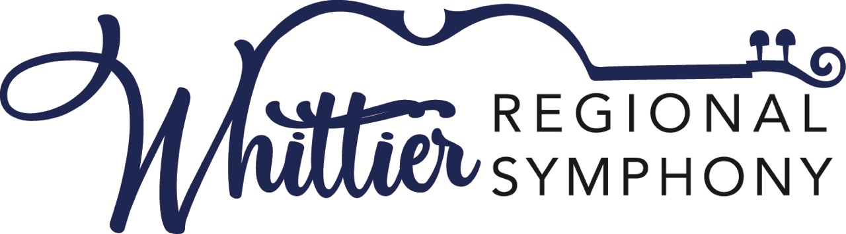

**Application for the Young Adult Artist Competition**

**Strings and Vocals**

**Saturday March 22nd, 2025**

Whittier College Memorial Chapel

13439 Philadelphia Street

Whittier, California 90601

The winner in each category will perform as a soloist with the Whittier Regional Symphony during the 2025-26 season. In addition, each winner will receive $1,000, and each runners-up a $500 cash award to further their music education.

**Who Can Apply**: Students who are residents of California or attending a California university, college, or school, or are studying with a private music teacher in California. All contestants must be at least 16 years old. String players cannot be older than 26 at the time of the competition; vocalists cannot be older than 30. ***The competition is limited to the first 15 eligible applicants.***

**What to Prepare**: Strings must prepare a full concerto or concert piece and a solo piece of contrasting style, both to be performed by memory. Voice contestants must prepare three songs: an aria from an opera, a song from a musical or operetta and a lieder or art song. All pieces are to be performed from memory. It is preferred that contestants provide their own accompanist, but if needed, one will be available on-site. If you require this service please make prior arrangements with chair, Dr. Fay Weber at 562 631 5262 or email [faycweber@gmail.com](mailto:faycweber@gmail.com). All contestants must bring an extra copy of all music to be performed for use by the judges.

Application deadline, along with payment of a $60 **non-refundable** application fee is due March 5, 2025. To make payment please select the Donate button on the website at [whittierregionalsymphony.org](https://whittierregionalsymphony.org/)

For more information, please call Dr. Fay Weber at 562 631 5262 or email questions to [faycweber@gmail.com](mailto:faycweber@gmail.com) or contact the Whittier Regional Symphony Association office at 562 698 8626.

**Whittier Regional Symphony Young Adult Artist Competition Application**

**Please complete the application form:**

Name:

Address:

Phone: Email address:

Age: Birthdate:

Contact name, phone and address if musician is under 18:

School/University/Music instructor/Instrument:

**String**: **Please list your full concerto or concert piece and a solo piece of contrasting style**

Full concerto or concert piece/composer:

Solo piece of contrasting style/composer:

**Voice:** **Please list three pieces**

Aria from an Opera/composer:

Song from an Operetta or Musical/composer:

Lieder or Art Song/composer:

Please outline any previous experience in competition or professional performance:

For more information contact Dr. Fay Weber at [faycweber@gmail.com](mailto:faycweber@gmail.com) or 562 631 5262 or the Whittier Regional Symphony at 562 698 8626. Sign-up at [whittierregionalsymphony.org](https://whittierregionalsymphony.org/)