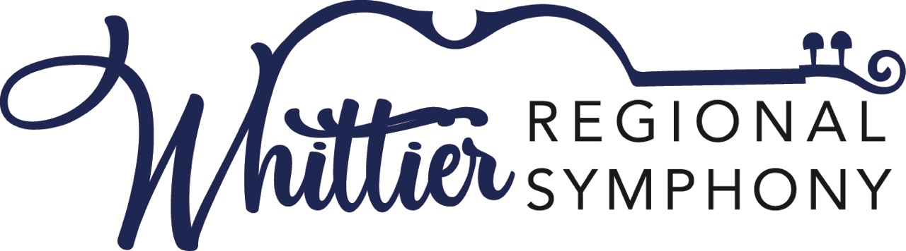

Application for the Young Artist Competition
Category 1: Piano
Category 2: Woodwind or Brass
Saturday, March 16, 2024
Whittier College Memorial Chapel
13439 Philadelphia Street
Whittier, California 90601

Award: The winner in each category will perform as a soloist at one of the orchestra’s concerts of the season, during the 2024-25 season. In addition, each winner will receive $1,000, and each runner-up a $500 cash award to further their music education.
Who Can Apply: Students who are residents of California or attending a California university, college, or school, or are studying with a private music teacher in California. Contestants cannot be older than 26 at the time of the competition. The competition is limited to the first 25 eligible applicants.
What to Prepare: Piano must prepare a full concerto or concert piece and a solo piece of contrasting style, both to be performed by memory. Woodwind and brass must prepare a full concerto or concert piece and a solo piece of contrasting style, to be performed by memory or with score as the contestant chooses.
Applicants must provide their own accompanist, and original scores of their music for the judges. Please contact the Young Artist Competition chairperson, Dr. Fay C Weber, for assistance in this area.
The application deadline for the competition is March 4th, 2024. Please pay the non-refundable application fee of $75 through the Donate tab on the website.
For more information, please call Dr. Fay Weber at 562 631 5262 or email questions to faycweber@gmail.com or the Whittier Regional Symphony Association office at 562 698 8626.
Please complete the application form below and email to Dr. Fay Weber at faycweber@gmail.com
Whittier Regional Symphony Young Artist Competition Application
Name: ____________________________________________________________________________
Address: __________________________________________________________________________
__________________________________________________________________________________
Phone: ___________________________________________________
Email Address: _____________________________________________
Age: ___________
Contact address if musician is under 18: _________________________________________________
School/University/Music instructor: _____________________________________________________
Instrument/Category: __________________________________________________________________
Please list your full concerto or concert piece and a solo piece of contrasting style and composers:
_______________________________________________________________________________________________________________________________________________________________________________________________________________________________________________________________________________________________________________________________________________________________________________________________________________________________________________________________________________________________________________________________________________________________________________________________________________________________________________________________________________________________________________________________________________________________________________________________________________________________________________________________________________________________________________________________________________________________________
Please outline any previous experience in competition or professional performance:
________________________________________________________________________________________________________________________________________________________________________________________________________________________________________________________________________________________________________________________________________________________________________________________________________________________________________________________________________________________________________________________________________________________________________________________________________________________________________________________________________________________________________

For more information contact Dr. Fay Weber at faycweber@gmail.com or 562 631 5262 or the Whittier Regional Symphony at 562 698 8626.

